1. Check if a Directory is Available

#!/bin/bash

Directory="/root/Scripts/d1/d2/d3"

if [ -d "$Directory" ];
then
echo "The Directory $Directory exist"
else
echo "The Directory $Directory does not exist"
fi

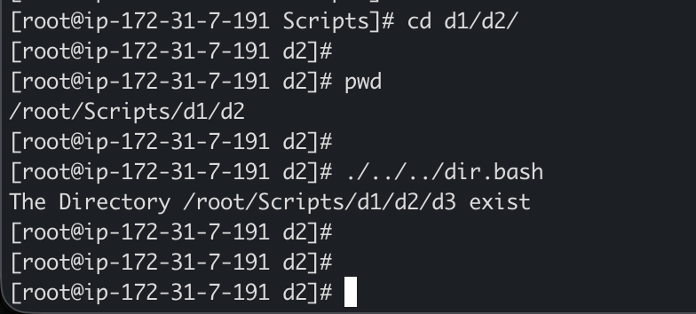

2. Create Multiple Files

#!/bin/bash

for i in {1..10}; do
touch "file_$i.txt"
echo "Created file_$i.txt"
done

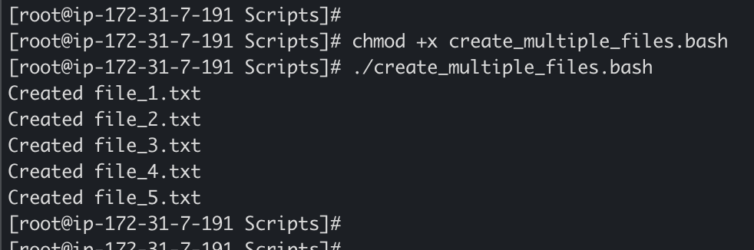

3. Backup a Directory

#!/bin/bash

SOURCE_DIR="/root/Scripts/temp"
BACKUP_DIR="/root/Scripts/backup"
DATE=$(date +%Y%m%d_%H%M%S)
BACKUP_NAME="backup_$DATE.tar.gz"

# Create backup directory if it doesn't exist
If [ -d "$BACKUP_DIR" ]; then
echo "Backup dir exist”
else
mkdir -p "$BACKUP_DIR"
fi

# Create compressed backup
tar -czf "$BACKUP_DIR/$BACKUP_NAME" "$SOURCE_DIR"

if [ $? -eq 0 ]; then
echo "Backup created successfully: $BACKUP_DIR/$BACKUP_NAME"
else
echo "Backup failed!"
exit 1
fi

# Optional: Remove backups older than 30 days
find "$BACKUP_DIR" -name "backup_*.tar.gz" -mtime +30 -delete

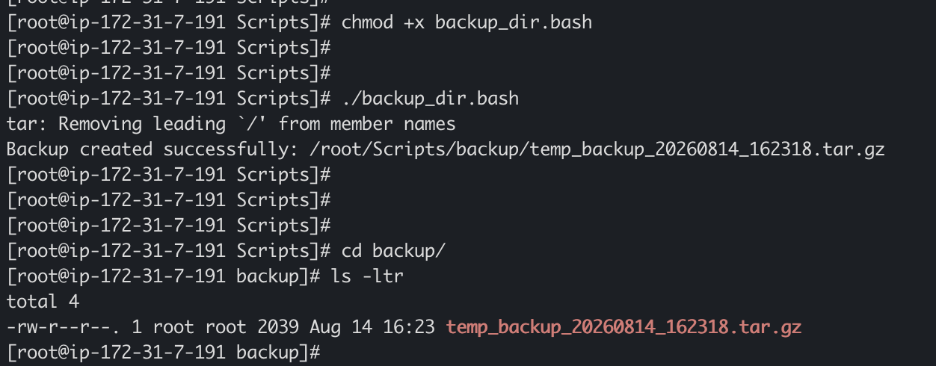

4. Install Nginx on Amazon Linux EC2 Server

#!/bin/bash

sudo dnf update -y

sudo dnf install nginx -y

sudo systemctl start nginx

sudo systemctl enable nginx

sudo systemctl status nginx

echo "nginx installed and running"

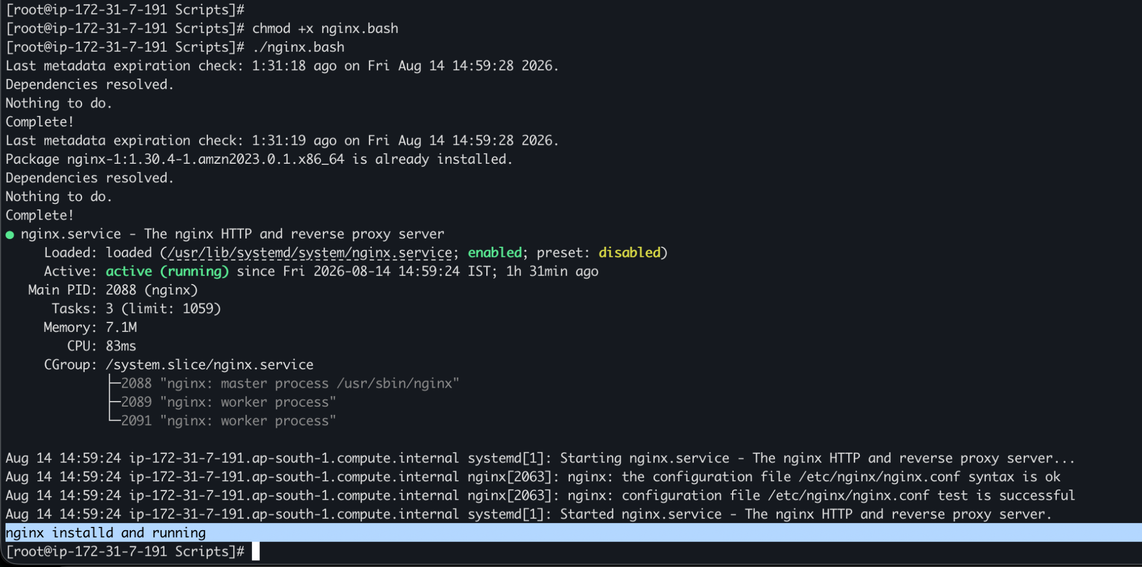

5. Install Apache Tomcat on EC2 Server

#!/bin/bash

sudo yum update -y

sudo yum install java-17-amazon-corretto-devel -y

TOMCAT_VERSION="11.0.24"
TOMCAT_URL="https://dlcdn.apache.org/tomcat/tomcat-11/v${TOMCAT_VERSION}/bin/apache-tomcat-11.0.24.tar.gz"

sudo useradd -m -U -d /opt/tomcat -s /bin/false tomcat

wget -q $TOMCAT_URL -O /tmp/tomcat.tar.gz
sudo tar -xzf /tmp/tomcat.tar.gz -C /opt/tomcat --strip-components=1

sudo chown -R tomcat:tomcat /opt/tomcat
sudo chmod +x /opt/tomcat/bin/*.sh

# Create systemd service file
sudo cat > /etc/systemd/system/tomcat.service << EOF
[Unit]
Description=Apache Tomcat Web Application Container
After=network.target

[Service]
Type=forking
User=tomcat
Group=tomcat
Environment="JAVA_HOME=/usr/lib/jvm/java-17-amazon-corretto.x86_64"
Environment="CATALINA_PID=/opt/tomcat/temp/tomcat.pid"
Environment="CATALINA_HOME=/opt/tomcat"
Environment="CATALINA_BASE=/opt/tomcat"
ExecStart=/opt/tomcat/bin/startup.sh
ExecStop=/opt/tomcat/bin/shutdown.sh
Restart=on-failure

[Install]
WantedBy=multi-user.target
EOF

# Reload systemd, start and enable Tomcat
sudo systemctl daemon-reload
sudo systemctl start tomcat
sudo systemctl enable tomcat
sudo systemctl status tomcat

echo "Tomcat installed and running on port 8080!"

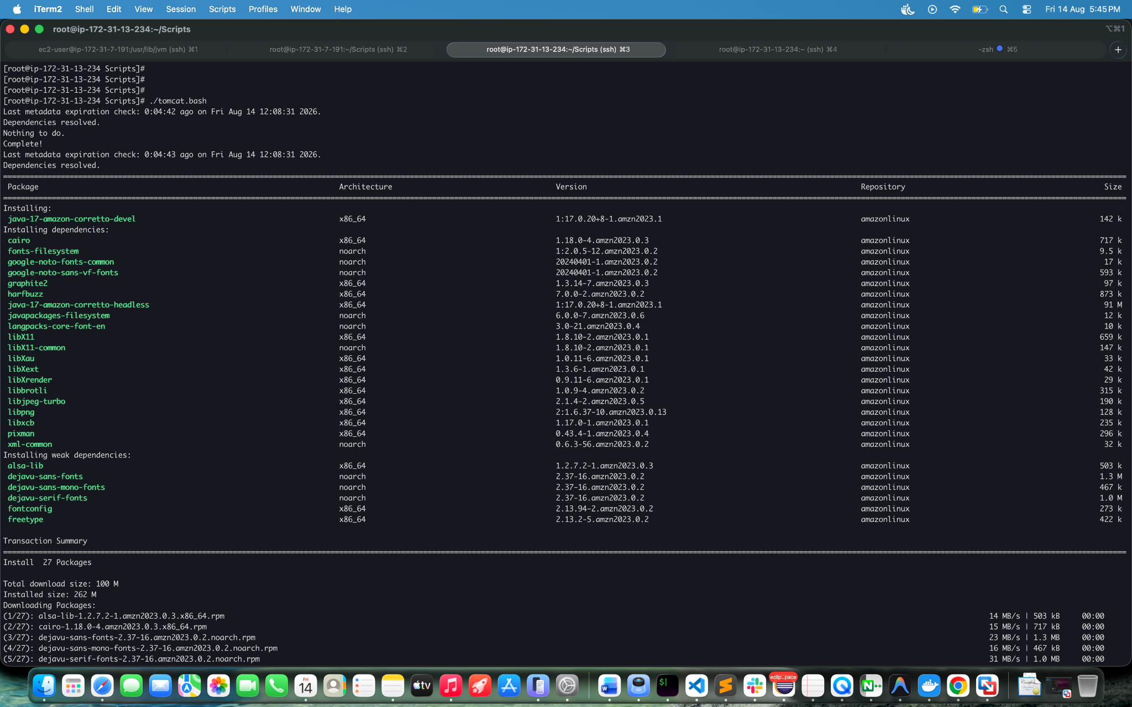

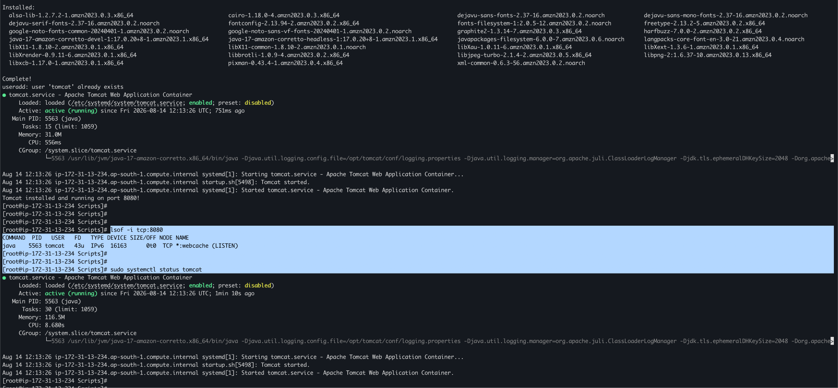

6. Check if Nginx is Running, Start if Not

#!/bin/bash

if systemctl is-active --quiet nginx; then
echo "Nginx is running."
else
echo "Nginx is not running. Attempting to start..."
sudo systemctl start nginx

# Verify if start was successful
if systemctl is-active --quiet nginx; then
echo "Nginx started successfully!"
else
echo "Failed to start Nginx. Please check the service."
exit 1
fi
fi

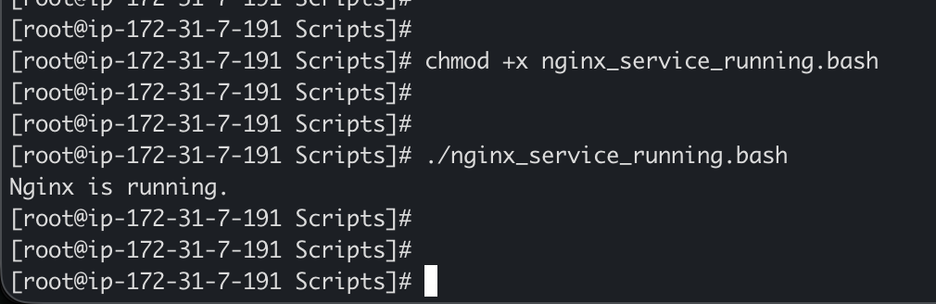

6. Create a bash script for a calculator.

#!/bin/bash

echo "Simple Calculator"
echo "1. Addition (+)"
echo "2. Subtraction (-)"
echo "3. Multiplication (*)"
echo "4. Division (/)"
echo "5. Modulus (%)"
echo "Enter your choice (1-5):"
read choice

echo "Enter first number:"
read num1
echo "Enter second number:"
read num2

case $choice in
1)
result=$((num1 + num2))
operation="Addition"
;;
2)
result=$((num1 - num2))
operation="Subtraction"
;;
3)
result=$((num1 * num2))
operation="Multiplication"
;;
4)
if [ $num2 -eq 0 ]; then
echo "Error: Division by zero!"
exit 1
fi
result=$(echo "scale=2; $num1 / $num2" | bc)
operation="Division"
;;
5)
result=$((num1 % num2))
operation="Modulus"
;;
*)
echo "Invalid choice!"
exit 1
;;
esac

echo "$operation of $num1 and $num2 is: $result"

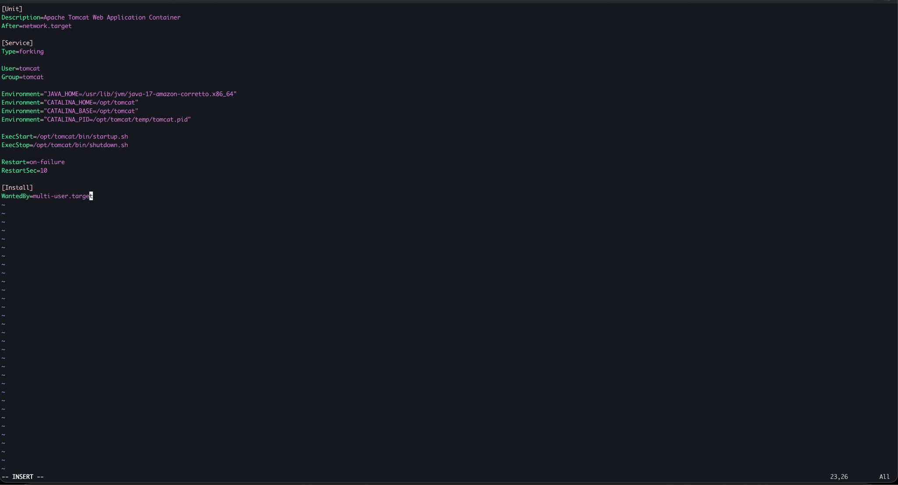

8. Check if Directory Exists, Create if Not

#!/bin/bash
DIRECTORY="/path/to/directory"

if [ -d "$DIRECTORY" ]; then
echo "Directory $DIRECTORY already exists."
else
echo "Directory $DIRECTORY does not exist. Creating now..."
mkdir -p "$DIRECTORY"
echo "Directory created successfully!"

# Optionally set permissions
chmod 755 "$DIRECTORY"
fi

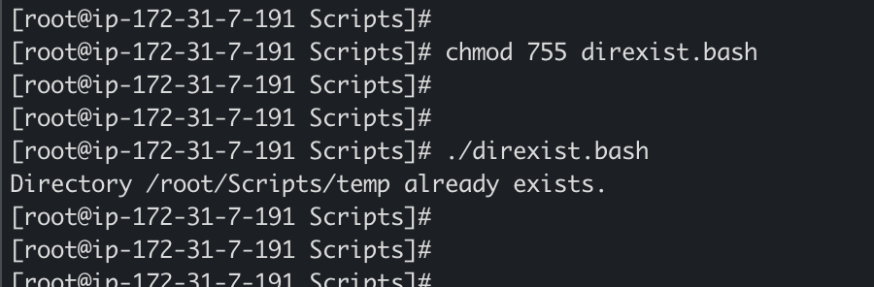

9. Delete Last 3 Lines of a File

#!/bin/bash

FILE="/root/Scripts/error.txt"

if [ ! -f "$FILE" ]; then
echo "File does not exist!"
exit 1
fi

# Get total lines
TOTAL_LINES=$(wc -l < "$FILE")

# Check if file has at least 3 lines
if [ $TOTAL_LINES -lt 3 ]; then
echo "File has less than 3 lines. Cannot delete the last 3 lines."
exit 1
fi

# Delete last 3 lines
LINES_TO_KEEP=$((TOTAL_LINES - 3))
head -n $LINES_TO_KEEP "$FILE" > temp_file
mv temp_file "$FILE"

echo "Last 3 lines deleted successfully!"
echo "Original lines: $TOTAL_LINES, Current lines: $(wc -l < "$FILE")"

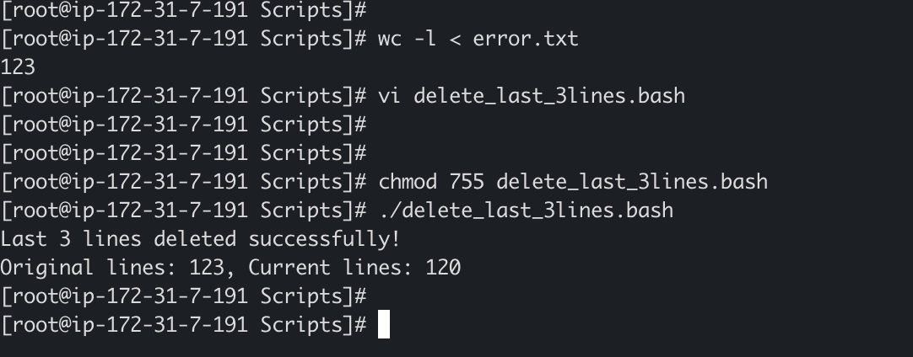

10. Monitor CPU and if it is more than 80% then Send Email Alert

#!/bin/bash

THRESHOLD=80
EMAIL="nayeemabdul@hotmail.com"

# Get CPU usage
CPU_USAGE=$(top -bn1 | grep "Cpu(s)" | awk '{print $2}' | cut -d. -f1)

if [ $CPU_USAGE -gt $THRESHOLD ]; then
MESSAGE="CPU Usage Alert: Current usage is $CPU_USAGE%, which exceeds threshold of $THRESHOLD%"

# Send email notification
echo "$MESSAGE" | mail -s "High CPU Usage Alert" $EMAIL

# Also log to a file
echo "$(date): $MESSAGE" >> /var/log/cpu_monitor.log
echo "Alert sent: $MESSAGE"
else
echo "CPU usage is within normal range: $CPU_USAGE%"
fi

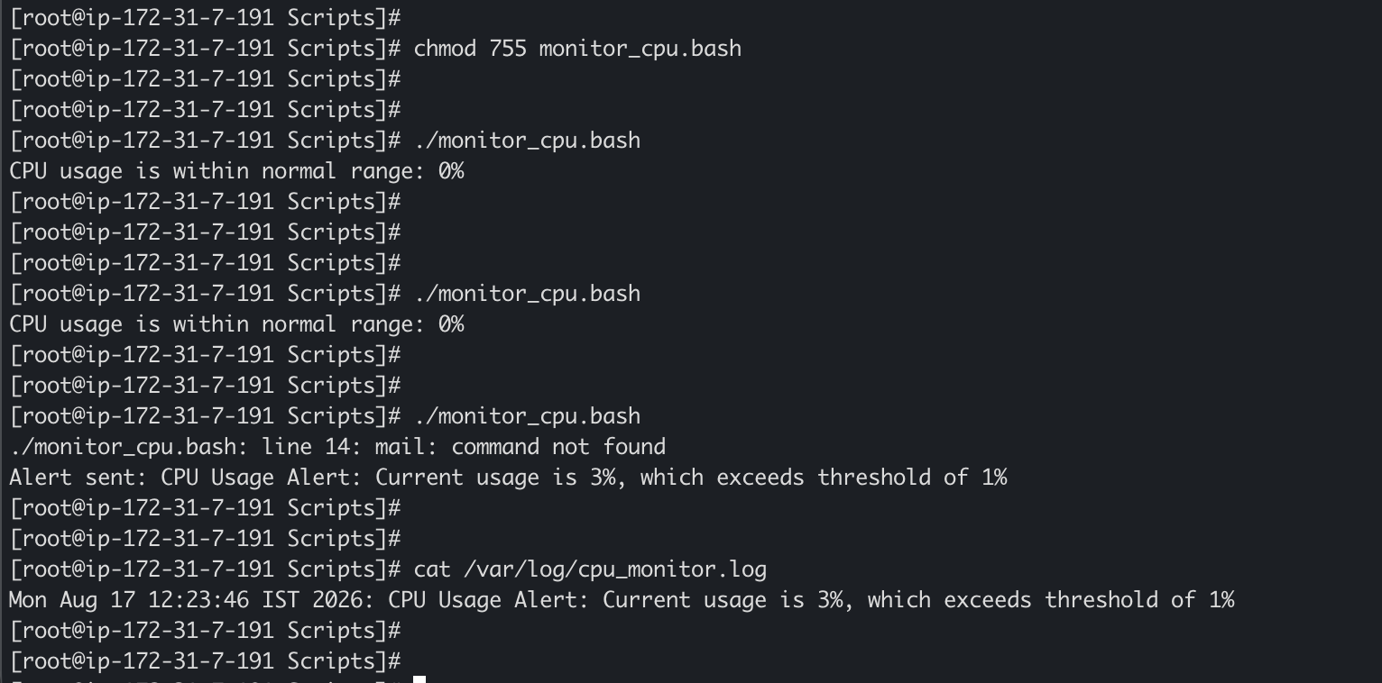

11. Monitor Disk Space and if it is more than 80% then Send Email Alert

#!/bin/bash

THRESHOLD=1
EMAIL="nayeemabdul@hotmail.com"
PARTITION="/dev/disk1s7" # Change this to your partition

# Get disk usage
DISK_USAGE=$(df -h "$PARTITION" | awk 'NR==2 {print $5}' | cut -d'%' -f1)

if [ $DISK_USAGE -gt $THRESHOLD ]; then
MESSAGE="Disk Space Alert: Current usage is $DISK_USAGE%, which exceeds threshold of $THRESHOLD%"

# Get detailed disk usage
DETAILS=$(df -h "$PARTITION")

# Send email notification
echo -e "$MESSAGE\n\nDisk Details:\n$DETAILS" | mail -s "High Disk Usage Alert" $EMAIL

# Also log to a file
echo "$(date): $MESSAGE" >> /var/log/disk_monitor.log
echo "Alert sent: $MESSAGE"
else
echo "Disk usage is within normal range: $DISK_USAGE%"
fi

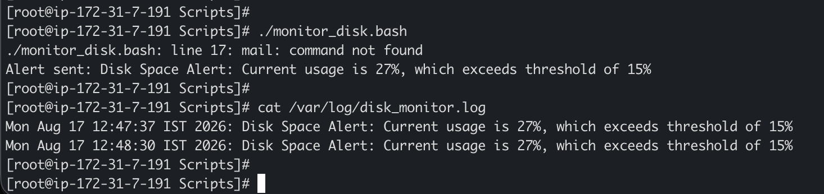

12. Monitor Memory and if it is more than 80% then Send Email Alert

#!/bin/bash

THRESHOLD=20
EMAIL="nayeemabdul@hotmail.com"

# Get memory usage percentage
MEMORY_USAGE=$(free | grep Mem | awk '{print ($3/$2) * 100.0}' | cut -d. -f1)

if [ $MEMORY_USAGE -gt $THRESHOLD ]; then
MESSAGE="Memory Usage Alert: Current usage is $MEMORY_USAGE%, which exceeds threshold of $THRESHOLD%"

# Get detailed memory info
DETAILS=$(free -h)

# Get top memory consuming processes
PROCESSES=$(ps aux --sort=-%mem | head -10)

# Send email notification
echo -e "$MESSAGE\n\nMemory Details:\n$DETAILS\n\nTop Memory Consuming Processes:\n$PROCESSES" | mail -s "High Memory Usage Alert" $EMAIL

# Also log to a file
echo "$(date): $MESSAGE" >> /var/log/memory_monitor.log
echo "Alert sent: $MESSAGE"
else
echo "Memory usage is within normal range: $MEMORY_USAGE%"
fi

